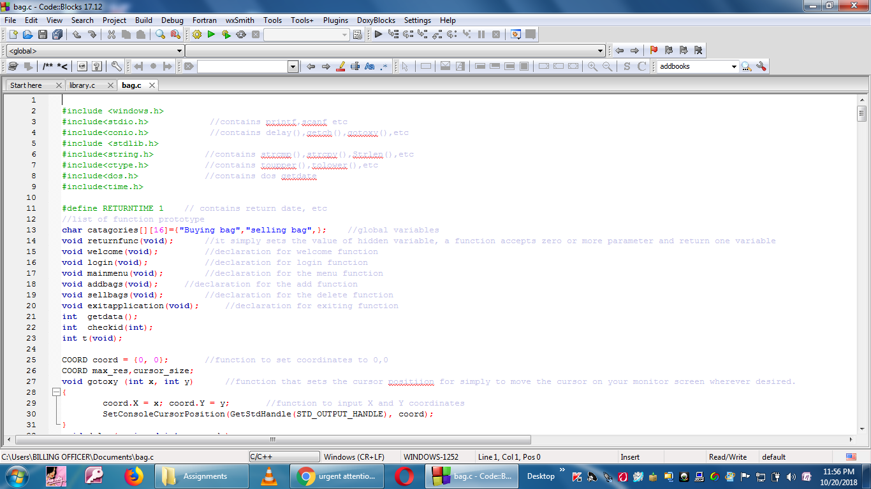

#include <windows.h>
#include<stdio.h> //contains printf,scanf etc
#include<conio.h> //contains delay(),getch(),gotoxy(),etc
#include <stdlib.h>
#include<string.h> //contains strcmp(),strcpy(),Strlen(),etc
#include<ctype.h> //contains toupper(),tolower(),etc
#include<dos.h> //contains dos getdate
#include<time.h>

#define RETURNTIME 1 // contains return date, etc
//list of function prototype
char catagories[][16]={"Buying bag","selling bag",}; //global variables
void returnfunc(void); //it simply sets the value of hidden variable, a function accepts zero or more parameter and return one variable
void welcome(void); //declaration for welcome function
void login(void); //declaration for login function
void mainmenu(void); //declaration for the menu function
void addbags(void); //declaration for the add function
void sellbags(void); //declaration for the delete function
void exitapplication(void); //declaration for exiting function
int getdata();
int checkid(int);
int t(void);
NB
These are the screen shots and the copy of it in a word document.

